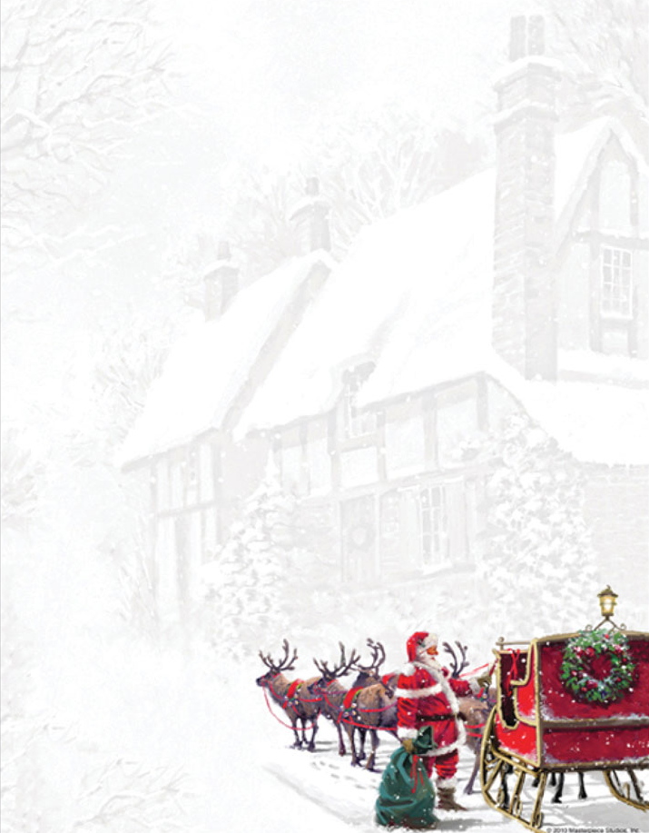
Christmas Vendor Market

Percentage of all sales go towards the Service Learning Kenya Group

THIS SATURDAY, November 24th
Including Vendors Such as:
- Thirty-One
- African Arts and Crafts
- Naturally a Goddess
- Clarkey’s Creations
- doTerra
- Cords of Steel
- Livin’ the Dream Designs
- Norwex
- Arbonne
- SweetLegs
- Registered Massage Therapist
- Wooden Decoy Ducks
- Sipology
- Christmas Crafts
- Tim Calkay Books
- Moffat Creek Designs
- Pampered Chef
- GelMoment Hand & Nail
- Stella & Dot
- Origami Owl
- Voxxlife
- Go Leather

AND MORE…

9 am – 3 pm
Monsignor Doyle CSS
185 Myers Rd. Cambridge
Raffles!

Kid’s Colouring Zone!

Amazing Range of Vendors!

For More Information Contact: ashley.odonnell@wcdsb.ca

